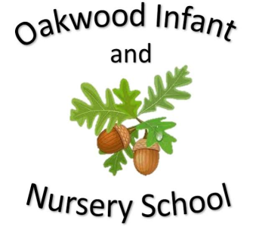

Maths

In maths children will be learning about 2D and 3D shapes. We will look at the different 2D shapes that can be seen in 3D shapes and learn about the properties of these shapes.

The children will also learn about fractions of shapes and numbers. They will recognise that 2/4 is the same as 1/2.

Addition, subtraction, multiplication and division is revisited throughout the year. Homework will link to the subjects being learnt at school.

Science

In science children will be learning about Animals including Humans. They will look at animals offspring and understand that not everything is born looking like its parent. The children will look at life cycles and describe the basic needs humans and animals have for survival. They will also investigate how humans and animals have offspring that grow into adults in different time scales. The importance of exercise, eating the right amounts of different types of food, and hygiene is also discussed and the children will perform an experiment to test the effects of exercise on their body.

English

Fiction Stories covered this half term include Handa’s Surprise and Farmer Duck. Children will be encouraged to learn these stories using Talk for Writing. The children will be encouraged to use imaginative story language and to use their ideas to help them write their own stories on a similar theme. The writing focus will be capital letters, full stops, conjunctions, adjectives, the use of question marks and checking the writing makes sense. We will also look at adding suffixes to change the meaning of words. Non Fiction will be writing instructions on how to make a cress seed head and the sequence of washing hands. Spellings sent home will link to daily phonics learning.

Computing

The children will learn about coding.

Geography

The children will learn about drawing simple maps and local routes. They will use an atlas to find places in the UK and countries and oceans in the world.

Our Year Two Spring 2 topic this half-term is....

The Farm

PSHE/RE The PSHE topic is digital wellbeing that teaches them how to be safe online. In RE the children will learn about special words and stories.

History

The children will learn about the history of farming and how the machinery used has changed over the last 100 years. They will look at the different methods of producing food and understand how these processes have changed. The children will understand that food was natural 100 years ago and had to be eaten in the season it grew in but now we have access to most food throughout the year. They will also investigate how jobs on the farm have changed due to modern technology.

P.E.

Ball skills

Each class will display the day’s that they are doing P.E.

Music

Charanga music programme.

Zoo time

Art and Design

The children will explore the life and work of Giuseppe Arcimboldo and his art made from fruit and vegetables. Children will then create their own picture based on this work.