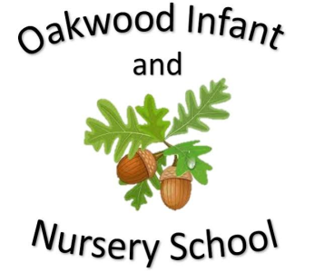

Maths

In maths children will be learning about money. We will look at the value of different coins and how we can make the same amounts by using different coins. We will add money together to buy different items and work out how much change we need to get back. The children will begin to learn about multiplication using the 2, 5 and 10 times tables.

Addition, subtraction, multiplication and division is revisited throughout the year. Homework will link to the subjects being learnt at school.

Science

In science children will be learning about Living Things and their Habitats. We will learn to tell the difference between things that are living, dead and things that have never been alive. We will make observations of a local habitat and the creatures that live there as well as investigate the conditions of a local microhabitat and how that affects the minibeasts that live there. We will learn about how living things are suited to live in their habitat and start to develop our understanding of how plants and animals depend on each other.

English

Fiction Stories covered this half term include the Messy Magpie and We All Went on Safari. Children will be encouraged to learn these stories using Talk for Writing. The children will be encouraged to use imaginative story language and to use their ideas to help them write their own stories on a similar theme. The writing focus will be capital letters, full stops, conjunctions, adjectives and checking their writing makes sense. Non Fiction will be learning about the continents and oceans of the world. Poetry will be London’s Burning.

Spellings sent home will link to daily phonics learning.

Computing

The children will learn to use the word programme.

Geography

The children will learn more about the continents and oceans of the world. They will investigate where hot and cold countries are.

Our Year Two Autumn 2 topic this half-term is....

What a Wonderful World

PSHE/RE

The PSHE topic is VIP’s. In RE the children will learn about symbols.

History

The children will learn about significant explorers and the impact they have had on our understanding of the world. We will compare explorers throughout history and the different challenges they faced. We will look at how equipment and satellite navigation has changed what is possible for us to do.

P.E.

Gymnastics

Each class will display the day’s that they are doing P.E.

Music

Charanga music programme.

Ho ho ho

Art and Design

The children will design and make a sculpture of something from nature out of clay. They will use tools to make the correct markings on it and then paint it.