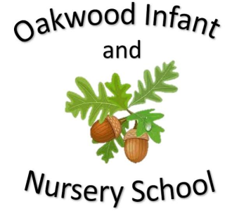

Maths

In maths children will be learning about multiplication and division and will practice the 2,5 and 10 times tables. They will understand that multiplication is repeated addition and that division is the inverse of multiplication. Children will learn about statistics. They will look at different ways data can be recorded including tally charts, pictograms and block diagrams. The children will begin to answer questions about this data. Homework will link to the subjects being learnt at school.

Computing

The children will learn about Online safety.

English

Fiction Stories covered this half term include Baboon on The Moon and The Way Back Home. Children will be encouraged to learn these stories using Talk for Writing. The children will be encouraged to use imaginative story language and to use their ideas to help them write their own stories on a similar theme. The writing focus will be capital letters, full stops, conjunctions, adjectives and checking their writing makes sense. Non Fiction will be writing facts about space and the planets. Poetry will be a mixture of space poems. Spellings sent home will link to daily phonics learning.

Science

In science children will be learning about The Environment and the different ways we can help to reduce waste and recycle for the good of the planet. Children will use their observations and their ideas to suggest ways of persuading people to use less energy. They will also learn about ways to save water and set up a test that shows how much water is saved when you turn the tap off while washing hands. The children will also look at climate change and how this is impacting the world.

Geography

Children will be learning about the weather and how the changes in the weather can impact us. They will learn about weather symbols and the dangers of adverse weather conditions.

Our Year Two Spring 1 topic this half-term is....

Space

PSHE/RE The PSHE topic is Aiming High. Children will be taught about working hard to reach their full potential. RE is special things in nature.

History

The children will learn about the history of Space Travel and the key points that have enabled us gain knowledge and understanding of space. They will learn about significant astronauts throughout history. The children will investigate who were the first people to stand on the moon and the global race to get there first. They will find out about space travel and what it is like to be on a spaceship. The children will research how spacesuits have changed over the years and why people want to travel in space.

P.E.

Gymnastics

Each class will display the day’s that they are doing P.E.

Music

Charanga music programme.

I Wanna Play in a Band

Art and Design

The children will explore the life and work of Vincent Van Gogh and his painting ‘Starry Night’. Children will then create their own picture based on this work.