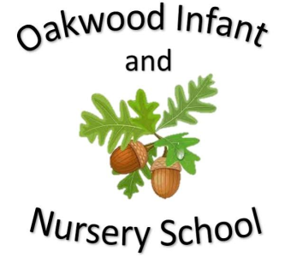

Maths

The children will learn be recognise the value of each digit in a 2-digit number and order numbers from 0-100. We will start to use the signs <, > and = to compare numbers. The children will add and subtract a variety of numbers including two 2-digit numbers.

Homework will link to the subjects being learnt at school.

Science

In science children will be learning about materials. We will identify different materials including wood, metal and glass and will think about how suitable they are for different uses. We will also be finding out about how the shape of some of these materials can be changed by conducting experiments. We will use language like bending, squashing, twisting, stretching and melting. The children will learn about the importance of recycling and the processes some of the materials go through during recycling.

English

Fiction Stories covered this half term include Vlad and the Great Fire of London. Children will be encouraged to learn these stories using Talk for Writing. The children will be encouraged to use imaginative story language and to use their ideas to help them write their own stories on a similar theme. The writing focus will be capital letters, full stops and checking their writing makes sense. The children will practice the correct formation of letters ready to begin joining their handwriting later in the year. Non Fiction will be writing facts about the Great Fire of London and investigating diary entries of Samuel Pepys. Spellings sent home will link to daily phonics learning.

Computing

The children will learn to use art programmes.

Geography

The children will look at the four countries and capital cities of the United Kingdom.

Our Year Two Autumn 1 topic this half-term is....

The Great Fire of London

Art and Design

The children will design and then make houses that replicate the design of the houses during the Great Fire of London.

PSHE/RE

The PSHE topic is thinking positive. In RE the children will learn about Special People.

History

The children will learn about the history of nursing. They will learn about Florence Nightingale, Mary Seacole and Edith Cavell and how they improved nursing. The children will learn about the hygiene conditions in the past and how these nurses worked so hard to change the conditions of hospitals to improve the life chances of the soldiers. The children will then go on to compare the lives of these nurses.

P.E.

Dance

Each class will display the day’s that they are doing P.E.

Music

Charanga music programme.

Hands, feet and heart.