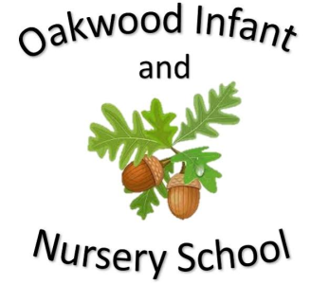

Maths

The children will learn about position and direction including describing turns as anti-clockwise and clockwise and repeating patterns. We will learn about measuring length and height.

We will also practise solving maths word problems.

Addition, subtraction, multiplication and division is revisited throughout the year.

Homework will link to the subjects being learnt at school.

Science

In science children will be conducting a variety of different experiments. They will be encouraged to ask simple questions and recognise that these questions can be answered in different ways. They will then be supported to use their observations to suggest answers to these questions. The children will gather and record the information they have found to help in answering these questions.

English

This half term the children will look at a selection of traditional tales. Children will be encouraged to learn these stories using Talk for Writing. The children will be encouraged to use imaginative story language and to use their ideas to help them write their own stories on a similar theme. The writing focus will be capital letters, full stops, conjunctions, adjectives, the use of question marks and checking the writing makes sense. We will also look at adding suffixes to change the meaning of words and the use of contractions.

Spellings sent home will link to daily phonics learning.

Computing

The children will learn to create a powerpoint.

Geography

The children will learn where in the world China is using maps and atlas’s. They will understand what life is like in China and compare this to life in the U.K.

Our Year Two Summer 1 topic this half-term is....

Traditional Tales

PSHE/RE The PSHE topic is Growing Up. In RE the children will learn about special places.

History

The children will learn about the history of English Kings and Queens. They will investigate the role of royalty and the significance of some Kings and Queens since 1066. The children will look at family trees and how the role of King or Queen is inherited. The children will learn about medieval banquets and what was eaten at one. Finally, the children will compare the lives of Elizabeth l and Queen Victoria.

P.E.

Send and Return

Each class will display the day’s that they are doing P.E.

Music

Charanga music programme.

Friendship Song

Art and Design

The children will design and create a hand puppet made from felt. They will be supported to sow it together and decorate the face.