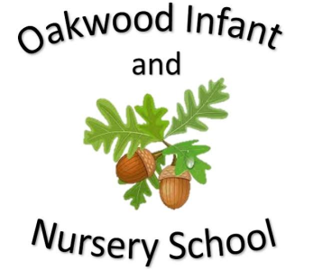

Maths

The children will be learning to tell the time. We will teach O’clock, half past, quarter past and quarter to and up to 5 minute intervals. The children will compare durations of time including minutes and hours. We will learn different types of measurement including measuring mass in g and kg, measuring capacity in l and ml and measure temperature in ˚C.

Addition, subtraction, multiplication and division is revisited throughout the year. Homework will link to the subjects being learnt at school.

Science

In science children will be learning about Plants and Growing. We will make predictions about the growing conditions that plants need to survive and plant a variety of seeds into different conditions to find out how plants need water, light and a suitable temperature to grow and stay healthy. We will plant seeds and bulbs and will measure the growth of these plants to observe the full life cycle of a plant. The children will then create a bar chart to show the growth of the plants over the previous weeks.

English

Fiction Stories covered this half term include stories from the same author The Lighthouse Keepers…... Children will be encouraged to learn these stories using Talk for Writing. The children will be encouraged to use imaginative story language and to use their ideas to help them write their own stories on a similar theme. The writing focus will be capital letters, full stops, conjunctions, adjectives, the use of question marks and checking the writing makes sense. We will also look at adding suffixes to change the meaning of words. Non Fiction will be the life of Grace Darling, beach safety and the RNLI. Spellings sent home will link to daily phonics learning.

Computing

The children will learn about using the internet.

Geography

The children will learn about the geographical locations of seasides. They will locate seaside towns on maps and view locations on google maps using aerial photographs.

Our Year Two Summer 2 topic this half-term is....

The Seaside

Art and Design

We will use different materials to create items found in a variety of habitats including shells, flowers and leaves. We will design our items before making them and use these designs to create our finished product out of clay. Finally, we will use paint and glitter to decorate them.

PSHE/RE

The PSHE topic is transition getting ready for year 3. In RE the children will learn about special ways of living

History

The children will learn about the history of the seaside and compare the seaside past and present. They will investigate what people wore, bathing huts and the entertainment that was available on the beach. We will look at the history Punch and Judy shows. The children will then learn about the history of Clacton Pier by looking at archive photos of the Pier and comparing it to how it is now.

P.E.

Sports Day practice

Each class will display the day’s that they are doing P.E.

Music

Charanga music programme.

Reflect, rewind and replay